Hands-on in this document
Objectives
- Explain the meaning of Unit testing and its difference on comparison with Functional testing
  - Smallest unit to test mocking dependencies
- List various types of testing
  - Unit testing, Functional testing, Automated testing, Performance testing
- Understand the benefit of automated testing
- Explain what is loosly coupled & testable design
  - Write code that is NOT dependent on the class for data.
- Write your first testing program to validate a calculator addition operation
  - TestFixture, Test
- Understand the need of [SetUp], [TearDown] & [Ignore] attributes.
- Explain the benefit of writing parameterised test cases.
  - TestCase
TestFixture & Test
Please download the application available here. This will be used to write Unit test cases
Follow the steps listed below to write the NUnit test cases for the application.
- Create a Unit test project(.Net Framework) in the solution provided.
- Add the CalcLibrary project as reference
- Create a class “CalculatorTests” to write all the test cases for the methods in the solution
- Use the ‘TestFixture’, ‘SetUp’ and ‘TearDown’ attributes, to declare, initialize and cleanup activities respectively
- Create a Test method to check the addition functionality
- Use the ‘TestCase’ attribute to send the inputs and the expected result
- Use Assert.That to check the actual and expected result match
Code:
Calculator.cs
namespace CalcLibrary
{
public class Calculator
{
public int Add(int a, int b)
{
return a + b;
}
}
}
UnitTest1.cs
using NUnit.Framework;
using CalcLibrary;

namespace nunit_p1
{
[TestFixture]
public class CalculatorTests
{
Calculator calc;

[SetUp]
public void Init()
{
calc = new Calculator();
Console.WriteLine("Setup Executed");
}

[TearDown]
public void Cleanup()
{
Console.WriteLine("Cleanup Executed");
}

[Test]
[TestCase(2, 3, 5)]
[TestCase(10, 20, 30)]
[TestCase(-1, 5, 4)]
public void Add_Test(int a, int b, int expected)
{
int actual = calc.Add(a, b);

Assert.That(actual, Is.EqualTo(expected));
}

[Test]
[Ignore("Temporary Ignore")]
public void Ignore_Test()
{
Assert.Fail();
}
}
}
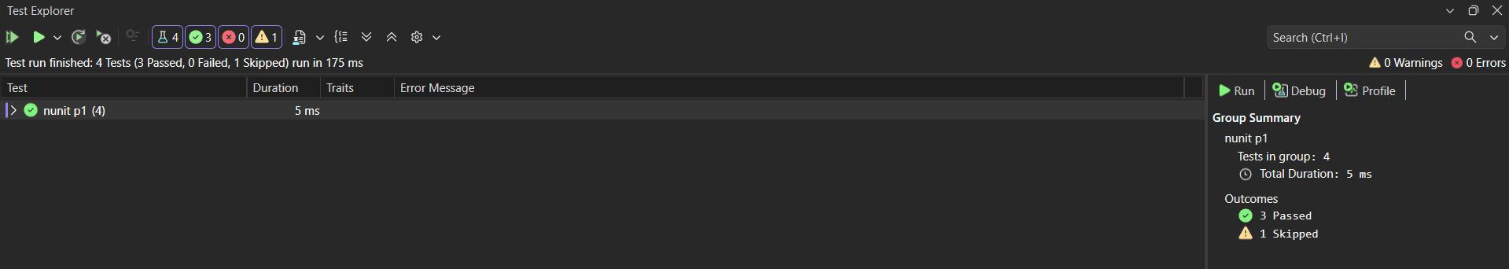

Output:

